In this module, we'll introduce and define data science and data itself. We'll also go over some of the resources that data scientists use to get help when they're stuck.

Key Concepts
- Use resources to get help with problems
- Define data science
- Define data

Welcome to the Data Scientist's Toolbox
Hello, and welcome to The Data Scientist's Toolbox, the first course in the Data Science Specialization series. Here, we will be going over the basics of data science and introducing you to the tools that will be used throughout the series.
Before we get started, we wanted to fill you in the reasoning behind some recent format changes. Please watch the next video, "Why Automated Videos?" to learn more.
The content of each lesson in this course is presented in two different formats, video and "ungraded plugin." The ungraded plugins are simply embedded web pages of the lessons in written form with accompanying illustrations.
You can use either format or both, depending on your preference.

This course is used in two different specializations. The Data Science Specialization is a 10-course sequence that covers the full length of the data science pipeline, whereas Data Science: Foundations using R covers only the first 5 courses in that sequence.
If you are taking Data Science: Foundations using R, please note that you will occasionally encounter references to the full 10-course Data Science Specialization. We apologize for any confusion that those references may cause.
If you would like to continue on to the remainder of the sequence after you complete Data Science: Foundations using R, you can do so by enrolling in Data Science: Statistics and Machine Learning.

W1 1 - Why Automated Videos
What’s the deal with these videos? And why do the videos say almost exactly the same thing as the printed lecture material? You have probably already noticed that the lectures and videos for this class are structured a little differently than in many MOOCs you have taken. We created this video to explain to you why we made this change and why we think it highlights the awesome power of R and data science.
We create a lot of massive online open courses at the Johns Hopkins Data Science Lab. We have created more than 30 courses on multiple platforms over the last 5 years. Our goal with these classes is to provide the best and most up to date information to the broadest audience possible.
But there are significant challenges to maintaining this much material online. R packages go out of date, new workflows are invented, and typos - oh, the typos!
We used to make these courses like many other universities. We’d create course material in the form of lecture slides, then we’d record videos of ourselves delivering those lectures. In some ways this was great - you actually got to hear our voices delivering your lectures, including all the “yawns”, “ums”, “buts”, and “so’s”. But the downside is that it is difficult and time consuming to update the content when we have to book a recording studio, set up special equipment, record ourselves delivering a lecture, edit those lectures, and then upload them to a system.
The result is that a lot of our lectures have been out of date, include errors, or don’t include the latest, best versions of workflows and pipelines. This has been a problem for a while, but as the number of courses we offer grows, it has become more and more of a challenge for us to keep them up to date.
So we started to think about how to solve this challenging problem. We realized that while recording and editing videos is extremely time consuming there is another type of content we can edit, update, and maintain much more frequently - regular old plain text documents. We aren’t the only ones who have thought this - massive online open course innovators like Lorena Barba have been saying that videos aren’t even necessary for these types of courses.
So when we sat down to develop our new process for creating and maintaining our courses we wanted to see if we could figure out how to make a class made entirely out of plain text documents. We broke down a massive online open course into its basic elements:
- Tutorials - these we can easily write in plain text formats like markdown or R markdown.
- Slides - these are easy enough to maintain and share if we make them with something like Google Slides.
- Assessments - here we can use a markup language to create quizzes and other assessments.
- Videos - this was the sticking point, how were we going to make videos from plain text documents?
By a happy coincidence, the data science and artificial intelligence communities were solving a huge part of this problem for us, improving text to voice synthesis! So we could now write a script for a video and use Amazon Polly to synthesize our voices!
To take advantage of this new technology we created two new R packages: ari and didactr.
Ari will take a script and a set of Google Slides and narrate the script over the slides using Amazon Polly. It will also generate the closed caption file needed to include captions and ensure that the videos are accessible to those with hearing impairment. Didactr automates several of the steps from creating the videos with ari to uploading them to YouTube, so that we can quickly make edits to the scripts or slides, remake the videos, re-upload them, and reduce our maintainence overhead for keeping our content fresh.
Whenever we change the text file or edit the slides, we can recreate the video in a couple of minutes. Everything is done in R. One of the coolest features of going to this new process is showing you how powerful the R programming language is. This is the main language you will learn in this specialization and we hope you will be able to build cool things like this system by the time you are done with our courses.
Why did we choose this approach instead of creating each piece of a lesson separately? Well, first, this process makes it a lot easier for us to maintain and update the courses. If you report an issue or find a mistake with a lesson, all we need to do is to change these two files and recreate the courses again. Therefore, we will have a more efficient way of maintaining the course content and updating it. Second, by using this process we have made our instruction more accessible. Since videos have transcripts and transcripts have voice over, the content is accessible by those of us who have disabilities. For everyone else, you can have a choice of reading versus listening versus watching the content as you wish.
Finally, a cool feature of using text to speech synthesis is that our videos will keep getting better as the voice synthesis software improves. It means that we can change the voice to different voices. Ultimately, it will allow us to translate our courses into different languages quickly and automatically using machine learning. We think this highlights the incredible power of data science and artificial intelligence to improve the world.
If you find the robot voice annoying, we get it. We know that the technology isn’t perfect yet. That’s why we’ve made the written lecture material reflect as closely as possible the video lectures. So you can pick how you want to consume our classes. We hope that this change will allow us to better serve you with the best content at the fastest speed. Thanks for participating in this new phase of course development with us!

W1 2 - What is Data Science

Welcome to the Data Scientist’s Toolbox
Hello, and welcome to The Data Scientist’s Toolbox, the first course in the Data Science Specialization series. Here, we will be going over the basics of data science and introducing you to the tools that will be used throughout the series.

What is data science?
So the first question you probably need answered going into this course is, “What is Data Science?” - and that is a great question. To different people, this means different things, but at its core, data science is using data to answer questions. This is a pretty broad definition, and that’s because it’s a pretty broad field!
Data science can involve:
- Statistics, computer science, mathematics
- Data cleaning and formatting
- Data visualization
An Economist Special Report sums up this melange of skills well - they state that a data scientist is broadly defined as someone:
“who combines the skills of software programmer, statistician and storyteller slash artist to extract the nuggets of gold hidden under mountains of data”
And by the end of these courses, hopefully you will feel equipped to do just that!

Why do we need data science?
One of the reasons for the rise of data science in recent years is the vast amount of data currently available and being generated. Not only are massive amounts of data being collected about many aspects of the world and our lives, but we simultaneously have the rise of inexpensive computing. This has created the perfect storm in which we have rich data and the tools to analyse it: Rising computer memory capabilities, better processors, more software and now, more data scientists with the skills to put this to use and answer questions using this data!
There is a little anecdote that describes the truly exponential growth of data generation we are experiencing. In the third century BC, the Library of Alexandria was believed to house the sum of human knowledge. Today, there is enough information in the world to give every person alive 320 times as much of it as historians think was stored in Alexandria’s entire collection.
And that is still growing.

What is big data?
We’ll talk a little bit more about big data in a later lecture, but it deserves an introduction here - since it has been so integral to the rise of data science. There are a few qualities that characterize big data. The first is volume. As the name implies, big data involves large datasets - and these large datasets are becoming more and more routine. For example, say you had a question about online video - well, YouTube has approximately 300 hours of video uploaded every minute! You would definitely have a lot of data available to you to analyse, but you can see how this might be a difficult problem to wrangle all of that data!
And this brings us to the second quality of big data: velocity. Data is being generated and collected faster than ever before. In our YouTube example, new data is coming at you every minute! In a completely different example, say you have a question about shipping times or routes. Well, most transport trucks have real time GPS data available - you could in real time analyse the trucks movements… if you have the tools and skills to do so!
The third quality of big data is variety. In the examples I’ve mentioned so far, you have different types of data available to you. In the YouTube example, you could be analysing video or audio, which is a very unstructured data set, or you could have a database of video lengths, views or comments, which is a much more structured dataset to analyse.
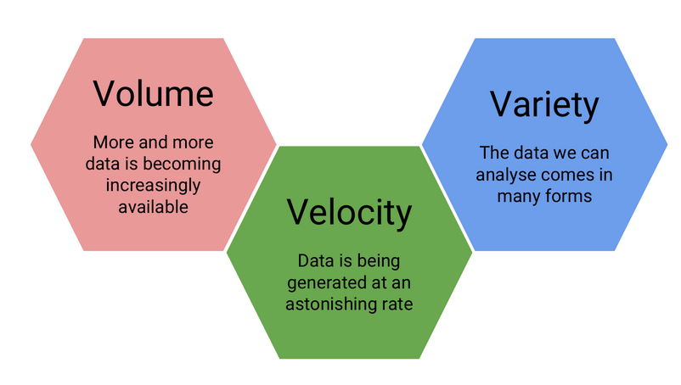
A summary of three qualities that characterize big data

What is a data scientist?
So we’ve talked about what data science is and what sorts of data it deals with, but something else we need to discuss is what exactly a data scientist is.
The most basic of definitions would be that a data scientist is somebody who uses data to answer questions. But more importantly to you, what skills does a data scientist embody?
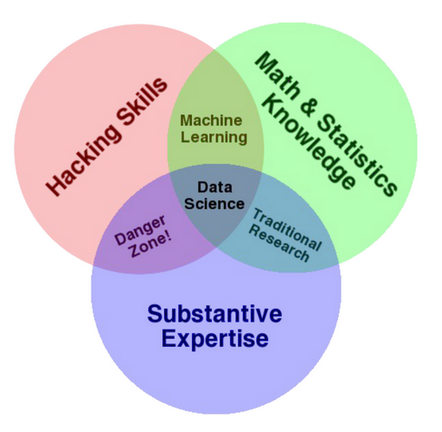
Drew Conway’s Venn diagram of data science
And to answer this, we have this illustrative Venn diagram, in which data science is the intersection of three sectors - Substantive expertise, hacking skills, and math and statistics.
To explain a little on what we mean by this, we know that we use data science to answer questions - so first, we need to have enough expertise in the area that we want to ask about in order to formulate our questions and to know what sorts of data are appropriate to answer that question. Once we have our question and appropriate data, we know from the sorts of data that data science works with, often times it needs to undergo significant cleaning and formatting - and this often takes computer programming slash “hacking” skills. Finally, once we have our data, we need to analyse it, and this often takes math and stats knowledge.
In this specialization, we’ll spend a bit of time focusing on each of these three sectors, but will primarily focus on math and statistics knowledge and hacking skills. For hacking skills, we’ll focus on teaching two different components: computer programming or at least computer programming with R, which will allow you to access data, play around with it, analyze it, and plot it. Additionally, we’ll focus on having you learn how to go out and get answers to your programming questions.
One reason data scientists are in such demand is that most of the answers aren’t already outlined in textbooks - a data scientist needs to be somebody who knows how to find answers to novel problems.

Why do data science?
Speaking of that demand, there is a huge need for individuals with data science skills. Not only are machine learning engineers, data scientists, and big data engineers among the top emerging jobs in 2017 according to LinkedIn, the demand far exceeds the supply.
Data scientist roles have grown over 650 percent since 2012, but currently 35,000 people in the US have data science skills, while hundreds of companies are hiring for those roles - even those you may not expect in sectors like retail and finance - supply of candidates for these roles cannot keep up with demand.
This is a great time to be getting in to data science - not only do we have more and more data, and more and more tools for collecting, storing, and analysing it, but the demand for data scientists is becoming increasingly recognized as important in many diverse sectors, not just business and academia.
Additionally, according to Glassdoor, in which they ranked the top 50 best jobs in America, Data Scientist is THE top job in the US in 2017, based on job satisfaction, salary, and demand.

Examples of data scientists
The diversity of sectors in which data science is being used is exemplified by looking at examples of data scientists.
One place we might not immediately recognize the demand for data science is in sports – Daryl Morey is the general manager of a US basketball team, the Houston Rockets. Despite not having a strong background in basketball, Morey was awarded the job as GM on the basis of his bachelor’s degree in computer science and his M.B.A. from M.I.T. He was chosen for his ability to collect and analyse data, and use that to make informed hiring decisions.
Another data scientist that you may have heard of is Hilary Mason. She is a co-founder of FastForward labs, a machine learning company recently acquired by Cloudera, a data science company, and is the Data Scientist in Residence at Accel. Broadly, she uses data to answer questions about mining the web and understanding the way that humans interact with each other through social media.
And finally, Nate Silver is one of the most famous data scientists or statisticians in the world today. He is founder and editor in chief at FiveThirtyEight - A website that
uses statistical analysis - hard numbers - to tell compelling stories about elections, politics, sports, science, economics and lifestyle.
He uses large amounts of totally free public data to make predictions about a variety of topics; most notably he makes predictions about who will win elections in the United States, and has a remarkable track record for accuracy doing so.

Data science in action!
One great example of data science in action is from 2009, in which researchers at Google analysed 50 million commonly searched terms over a five year period, and compared them against CDC data on flu outbreaks. Their goal was to see if certain searches coincided with outbreaks of the flu. One of the benefits of data science and using big data is that it can identify correlations; in this case, they identified 45 words that had a strong correlation with the CDC flu outbreak data. With this data, they have been able to predict flu outbreaks based solely off of common Google searches! Without this mass amounts of data, these 45 words could not have been predicted beforehand.

What will we teach you in this course?
Now that you have had this introduction into data science, all that really remains to cover here is a summary of what it is that we will be teaching you throughout this course. To start, we’ll go over the basics of R. R is the main programming language that we will be working with in this course track, so a solid understanding of what it is, how it works and getting it installed on your computer is a must. We’ll then transition into RStudio - which is a very nice graphical interface to R, that should make your life easier! We’ll then talk about version control, why it is important and how to integrate it into your work. And once you have all of these basics down, you’ll be all set to apply these tools to answering your very own data science questions!
Looking forward to learning with you! Let’s get to it!

w1 2 - What is Data
Since we’ve spent some time discussing what data science is, we should spend some time looking at what exactly data is.

Definitions of “data”
First, let’s look at what a few trusted sources consider data to be.
First up, we’ll look at the Cambridge English Dictionary, which states that data is:
Information, especially facts or numbers, collected to be examined and considered and used to help decision-making.
Second, we’ll look at the definition provided by Wikipedia, which is:
A set of values of qualitative or quantitative variables.
These are slightly different definitions and they get at different components of what data is. Both agree that data is values or numbers or facts, but the Cambridge definition focuses on the actions that surround data - data is collected, examined and most importantly, used to inform decisions. We’ve focused on this aspect before - we’ve talked about how the most important part of data science is the question and how all we are doing is using data to answer the question. The Cambridge definition focuses on this.
The Wikipedia definition focuses more on what data entails. And although it is a fairly short definition, we’ll take a second to parse this and focus on each component individually.
So, the first thing to focus on is “a set of values” - to have data, you need a set of items to measure from. In statistics, this set of items is often called the population. The set as a whole is what you are trying to discover something about. For example, that set of items required to answer your question might be all websites or it might be the set of all people coming to websites, or it might be a set of all people getting a particular drug. But in general, it’s a set of things that you’re going to make measurements on.
The next thing to focus on is “variables” - variables are measurements or characteristics of an item. For example, you could be measuring the height of a person, or you are measuring the amount of time a person stays on a website. On the other hand, it might be a more qualitative characteristic you are trying to measure, like what a person clicks on on a website, or whether you think the person visiting is male or female.
Finally, we have both qualitative and quantitative variables. Qualitative variables are, unsurprisingly, information about qualities. They are things like country of origin, sex, or treatment group. They’re usually described by words, not numbers, and they are not necessarily ordered. Quantitative variables on the other hand, are information about quantities. Quantitative measurements are usually described by numbers and are measured on a continuous, ordered scale; they’re things like height, weight and blood pressure.
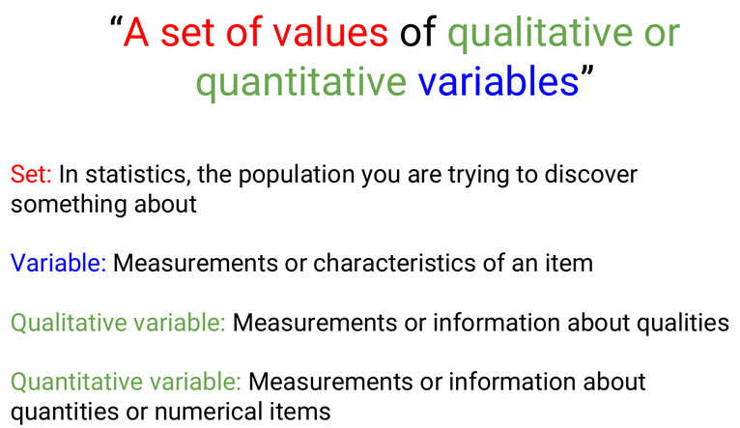
A summary of the concepts present in the Wikipedia definition of data
So, taking this whole definition into consideration we have measurements (either qualitative or quantitative) on a set of items making up data - not a bad definition.

What can data look like? (rarely)
When we were going over the definitions, our examples of variables and measurements (country of origin, sex, height, weight) are pretty basic examples; you can easily envision them in a nice looking spreadsheet, with individuals along one side of the table, and the information for those variables along the other side.
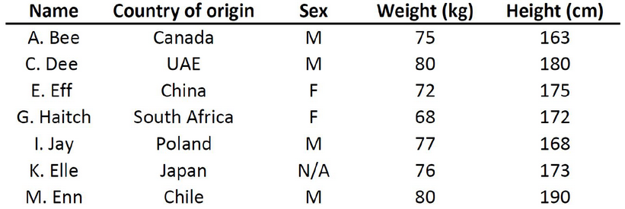
An example of a structured dataset - a spreadsheet of individuals (first initial, last name) and their country of origin, sex, height, and weight)
Unfortunately, this is rarely how data is presented to you. The data sets we commonly encounter are much messier, and it is our job to extract the information we want, corral it into something tidy like the imagined table above, analyse it appropriately, and often, visualize our results.

More common types of messy data
Here are just some of the data sources you might encounter and we’ll briefly look at what a few of these data sets often look like or how they can be interpreted, but one thing they have in common is the messiness of the data - you have to work to extract the information you need to answer your question.
- Sequencing data
- Population census data
- Electronic medical records (EMR), other large databases
- Geographic information system (GIS) data (mapping)
- Image analysis and image extrapolation
- Language and translations
- Website traffic
- Personal/Ad data (eg: Facebook, Netflix predictions, etc)

Messy data: Sequencing
One type of data, that I work with regularly, is sequencing data. This data is generally first encountered in the FASTQ format, the raw file format produced by sequencing machines. These files are often hundreds of millions of lines long, and it is our job to parse this into an understandable and interpretable format and infer something about that individual’s genome. In this case, this data was interpreted into expression data, and produced a plot called a “volcano plot”.
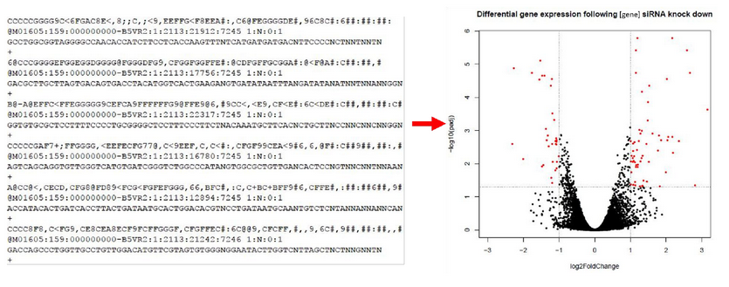
A volcano plot is produced at the end of a long process to wrangle the raw FASTQ data into interpretable expression data

Messy data: Census information
One rich source of information is country wide censuses. In these, almost all members of a country answer a set of standardized questions and submit these answers to the government. When you have that many respondants, the data is large and messy; but once this large database is ready to be queried, the answers embedded are important.Here we have a very basic result of the last US census - in which all respondants are divided by sex and age, and this distribution is plotted in this population pyramid plot.
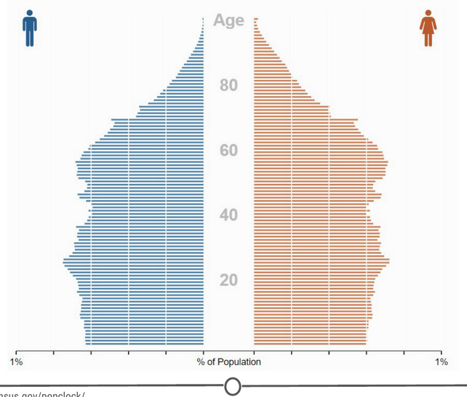
The US population is stratified by sex and age to produce a population pyramid plot
Here is the US census website and some tools to help you examine it, but if you aren’t from the US, I urge you to check out your home country’s census bureau (if available) and look at some of the data there!

Messy data: Electronic medical records (EMR)
Electronic medical records are increasingly prevalent as a way to store health information, and more and more population based studies are using this data to answer questions and make inferences about populations at large, or as a method to identify ways to improve medical care. For example, if you are asking about a population’s common allergies, you will have to extract many individuals’ allergy information, and put that into an easily interpretable table format where you will then perform your analysis.

Messy data: Image analysis/extrapolation
A more complex data source to analyse are images/videos. There is a wealth of information coded in an image or video, and it is just waiting to be extracted. An example of image analysis that you may be familiar with is when you upload a picture to Facebook and not only does it automatically recognize faces in the picture, but then suggests who they may be. A fun example you can play with is the DeepDream software that was originally designed to detect faces in an image, but has since moved on to more artistic pursuits.

The DeepDream software is trained on your image and a famous painting and your provided image is then rendered in the style of the famous painter
There is another fun Google initiative involving image analysis, where you help provide data to Google’s machine learning algorithm… by doodling!

Data is of secondary importance
Recognizing that we’ve spent a lot of time going over what data is, we need to reiterate - Data is important, but it is secondary to your question. A good data scientist asks questions first and seeks out relevant data second.
Admittedly, often the data available will limit, or perhaps even enable, certain questions you are trying to ask. In these cases, you may have to reframe your question or answer a related question, but the data itself does not drive the question asking.

Summary
In this lesson we focused on data - both in defining it and in exploring what data may look like and how it can be used.
First, we looked at two definitions of data, one that focuses on the actions surrounding data, and another on what comprises data. The second definition embeds the concepts of populations, variables, and looks at the differences between quantitative and qualitative data.
Second, we examined different sources of data that you may encounter, and emphasized the lack of tidy datasets. Examples of messy datasets, where raw data needs to be wrangled into an interpretable form, can include sequencing data, census data, electronic medical records, etc. And finally, we return to our beliefs on the relationship between data and your question and emphasize the importance of question-first strategies. You could have all the data you could ever hope for, but if you don’t have a question to start, the data is useless.

W1 3 - Getting Help
One of the main skills you are going to be called upon for as a data scientist is your ability to solve problems. And sometimes to do that, you need help. The ability to solve problems is at the root of data science; so the importance of being able to do so is paramount. In this lesson, we are going to equip you with some strategies to help you when you get stuck with a problem and need some help! Much of this information has been compiled from Roger Peng’s video on “Getting Help” and Eric Raymond’s “How to ask questions the smart way” - so definitely check out those resources!

Why is knowing how to get help important?
First off, this course is not like a standard class you have taken before where there may be 30 to 100 people and you have access to your professor for immediate help. In this class, at any one time there can be thousands of students taking the class; no one person could provide help to all of these people, all of the time! So we’ll introduce you to some strategies to deal with getting help in this course.
Also, as we said earlier, being able to solve problems is often one of the core skills of a data scientist. Data science is new; you may be the first person to come across a specific problem and you need to be equipped with skills that allow you to tackle problems that are both new to you and to the community!
Finally, troubleshooting and figuring out solutions to problems is a great, transferable skill! It will serve you well as a data scientist, but so much of what any job often entails is problem solving. Being able to think about problems and get help effectively is of benefit to you in whatever career path you find yourself in!

Before you ask for help
Before you begin asking others for help on your problem, there are a few steps you can take on your own. Oftentimes, the fastest answer is one you find for yourself.
One of your first stops for data analysis problems should be reading the manuals or help files (for R problems, try typing ?command) – if you post a question on a forum that is easily answered by the manual, you will often get a reply of “Read the manual” … which is not the easiest way to get at the answer you were going for!
Next steps are searching on Google and searching relevant forums. Common forums for data science problems include StackOverflow and CrossValidated. Additionally, for you in this class, there is a course forum that is a great resource and super helpful! Before posting a question to any forum, try and double check that it hasn’t been asked before, using the forums’ search functions.
While you are Googling, things to pay attention to and look for are: tutorials, FAQs, or vignettes of whatever command or program is giving you trouble. These are great resources to get you started – either in telling you the language/words to use in your next searches, or outright showing you how to do something.

First steps for solving coding problems
As you get further into this course and using R, you may run into coding problems and errors and there are a few strategies you should have ready to deal with these. In my experience, coding problems generally fall into two categories: your command produces no data and spits out an error message OR your command produces an output, but it is not at all what you wanted. These two problems have different strategies for dealing with them.
If it’s a problem producing an error message:
- Check for typos!
- Read the error message and make sure you understand it
- Google the error message, exactly
I’ve been there – you type out a command and all you get are lines and lines of angry red text telling you that you did something wrong. And this can be overwhelming. But taking a second to check over your command for typos and then carefully reading the error message solves the problem in nearly all of the cases. The error messages are there to help you – it is the computer telling you what went wrong. And when all else fails, you can be pretty assured that somebody out there got the same error message, panicked and posted to a forum – the answer is out there.
On the other hand, if you get an output, but it isn’t what you expected:
- Consider how the output was different from what you expected
- Think about what it looks like the command actually did, why it would do that, and not what you wanted
Most problems like this are because the command you provided told the program to do one thing and it did that thing exactly… it just turns out what you told it to do wasn’t actually what you wanted! These problems are often the most frustrating – you are so close but so far! The quickest way to figuring out what went wrong is looking at the output you did get, comparing it to what you wanted, and thinking about how the program may have produced that output instead of what you wanted. These sorts of problems give you plenty of practice thinking like a computer program!

Next steps
Alright, you’ve done everything you are supposed to do to solve the problem on your own – you need to bring in the big guns now: other people!
Easiest is to find a peer with some experience with what you are working on and ask them for help/direction. This is often great because the person explaining gets to solidify their understanding while teaching it to you, and you get a hands on experience seeing how they would solve the problem. In this class, your peers can be your classmates and you can interact with them through the course forum (double check your question hasn’t been asked already!).
But, outside of this course, you may not have too many data science savvy peers – what then?
“Rubber duck debugging” is a long held tradition of solitary programmers everywhere. In the book “The Pragmatic Programmer,” there is a story of how stumped programmers would explain their problem to a rubber duck, and in the process of explaining the problem, identify the solution.
Wikipedia explains it well:
Many programmers have had the experience of explaining a programming problem to someone else, possibly even to someone who knows nothing about programming, and then hitting upon the solution in the process of explaining the problem. In describing what the code is supposed to do and observing what it actually does, any incongruity between these two becomes apparent.
So next time you are stumped, bring out the bath toys!

When all else fails: posting to forums
You’ve done your best. You’ve searched and searched. You’ve talked with peers. You’ve done everything possible to figure it out on your own. And you are still stuck. It’s time. Time to post your question to a relevant forum.
Before you go ahead and just post your question, you need to consider how you can best ask your question to garner (helpful) answers.

How to effectively ask questions on forums
Details to include:
- The question you are trying to answer
- How you approached the problem, what steps you have already taken to answer the question
- What steps will reproduce the problem (including sample data for troubleshooters to work from!)
- What was the expected output
- What you saw instead (including any error messages you received!)
- What troubleshooting steps you have already tried
- Details about your set-up, eg: what operating system you are using, what version of the product you have installed (eg: R, Rpackages)
- Be specific in the title of your questions!

How to title forum posts
Most of these details are self-explanatory, but there can be an art to titling your posting. Without being specific, you don’t give your potential helpers a lot to go off of – they don’t really know what the problem is and if they are able to help you.
Bad:
- HELP! Can’t fit linear model!
- HELP! Don’t understand PCA!
These titles don’t give your potential helpers a lot to go off of – they don’t really know what the problem is and if they are able to help you. Instead, you need to provide some details about what you are having problems with. Answering what you were doing and what the problem is are two key pieces of information that you need to provide. This way somebody who is on the forum will know exactly what is happening and that they might be able to help!
Better:
- R 3.4.3 lm() function produces seg fault with large data frame (Windows 10)
- Applied PCA to a matrix - what are U, D, and Vt?
Even better:
- R 3.4.3 lm() function on Windows 10 – seg fault on large dataframe
- Using principle components to discover common variation in rows of a matrix, should I use, U, D or Vt?
Use titles that focus on the very specific core problem that you are trying to get help with. It signals to people that you are looking for a very specific answer; the more specific the question, often, the faster the answer.

Forum etiquette
Following a lot of the tips above will serve you well in posting on forums and observing forum etiquette. You are asking for help, you are hoping somebody else will take time out of their day to help you – you need to be courteous. Often this takes the form of asking specific questions, doing some troubleshooting of your own, and giving potential problem solvers easy access to all the information they need to help you. Formalizing some of these do’s and don’t’s, you get the following lists:
Do’s
- Read the forum posting guidelines
- Make sure you are asking your question on an appropriate forum!
- Describe the goal
- Be explicit and detailed in your explanation
- Provide the minimum information required to describe (and replicate) the problem
- Be courteous! (Please and thank you!)
- Follow up on the post OR post the solution
Let’s take a few seconds to talk a bit about this last point, as we have touched on the others already. First, what do we mean by “follow up on the post”? You’ve asked your question and you’ve received several answers and lo and behold one of them works! You are all set, get back to work! No! Go back to your posting, reply to the solution that worked for you, explaining that they fixed your problem and thanking them for their solution! Not only do the people helping you deserve thanks, but this is helpful to anybody else who has the same problem as you, later on. They are going to do their due diligence, search the forum and find your post – it is so helpful for you to have flagged the answer that solved your problem.
Conversely, while you are waiting for a reply, perhaps you stumble upon the solution (go you!) – don’t just close the posting or never check back on it. One, people who are trying to help you may be replying and you are functionally ignoring them, or two, if you close it with no solution, somebody with the same problem won’t ever learn what your solution was! Make sure to post the solution and thank everybody for their help!
Don’t’s:
- Immediately assume you have found a bug
- Post homework questions
- Cross post on multiple forums
- Repost if you don’t immediately get a response
These are all pretty clear guidelines. Nobody wants to help somebody who assumes that the root cause of the problem isn’t because they have made a mistake, but that there is something wrong with a program. Spoiler alert, it’s (almost) always because you made a mistake. Similarly, nobody wants to do your homework for you, they want to help somebody who is genuinely trying to learn – not find a short cut.
Additionally, for people who are active on multiple forums, it is always aggravating when the same person posts the same question on five different forums…. Or when the same question is posted on the same forum repeatedly. Be patient – pick the most relevant forum for your purposes, post once, and wait.

Summary
In this lesson, we look at how to effectively get help when you run into a problem. This is important for this course, but also for your future as a data scientist!
We first looked at strategies to use before asking for help, including reading the manual, checking the help files, and searching Google and appropriate forums. We also covered some common coding problems you may face and some preliminary steps you can take on your own, including paying special attention to error messages and examining how your code behaved compared to your goal.
Once you’ve exhausted these options, we turn to other people for help. We can ask peers for help or explain our problems to our trusty rubber ducks (be it an actual rubber duck or an unsuspecting coworker!). Our course forum is also a great resource for you all to talk with many of your peers! Go introduce yourself!
And if all else fails, we can post on forums (be it in this class or at another forum, like StackOverflow), with very specific, reproducible questions. Before doing so, be sure to brush up on your forum etiquette - it never hurt anybody to be polite! Be a good citizen of our forums!
There is an art to problem solving, and the only way to get practice is to get out there and start solving problems! Get to it!

W1 4 - The Data Science Process
In the first few lessons of this course we discussed what data and data science are, and ways to get help. What we haven’t yet covered is what an actual data science project looks like. To do so, we’ll first step through an actual data science project, breaking down the parts of a typical project and then provide a number of links to other interesting data science projects. Our goal in this lesson is to expose you to the process one goes through as they carry out data science projects.

The Parts of a Data Science Project
Every Data Science Project starts with a question that is to be answered with data. That means that forming the question is an important first step in the process. The second step is finding or generating the data you’re going to use to answer that question. With the question solidified and data in hand, the data are then analyzed, first by exploring the data and then often by modeling the data, which means using some statistical or machine learning techniques to analyze the data and answer your question. After drawing conclusions from this analysis, the project has to be communicated to others. Sometimes this is a report you send to your boss or team at work. Other times it’s a blog post. Often it’s a presentation to a group of colleagues. Regardless, a data science project almost always involves some form of communication of the projects’ findings. We’ll walk through these steps using a data science project example below.

A Data Science Project Example
For this example, we’re going to use an example analysis from a data scientist named Hilary Parker. Her work can be found on her blog, and the specific project we’ll be working through here is from 2013 and titled “Hilary: the most poisoned baby name in US history”. To get the most out of this lesson, click on that link and read through Hilary’s post. Once you’re done, come on back to this lesson and read through the breakdown of this post.
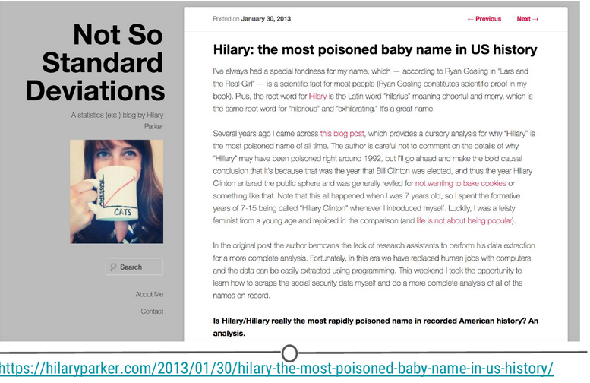
Hilary’s blog post

The Question
When setting out on a data science project, it’s always great to have your question well-defined. Additional questions may pop up as you do the analysis, but knowing what you want to answer with your analysis is a really important first step. Hilary Parker’s question is included in bold in her post. Highlighting this makes it clear that she’s interested in answer the following question:
Is Hilary/Hillary really the most rapidly poisoned name in recorded American history?

The Data
To answer this question, Hilary collected data from the Social Security website. This dataset included the 1,000 most popular baby names from 1880 until 2011.

Data Analysis
As explained in the blog post, Hilary was interested in calculating the relative risk for each of the 4,110 different names in her dataset from one year to the next from 1880 to 2011. By hand, this would be a nightmare. Thankfully, by writing code in R, all of which is available on GitHub, Hilary was able to generate these values for all these names across all these years. It’s not important at this point in time to fully understand what a relative risk calculation is (although Hilary does a great job breaking it down in her post!), but it is important to know that after getting the data together, the next step is figuring out what you need to do with that data in order to answer your question. For Hilary’s question, calculating the relative risk for each name from one year to the next from 1880 to 2011 and looking at the percentage of babies named each name in a particular year would be what she needed to do to answer her question.
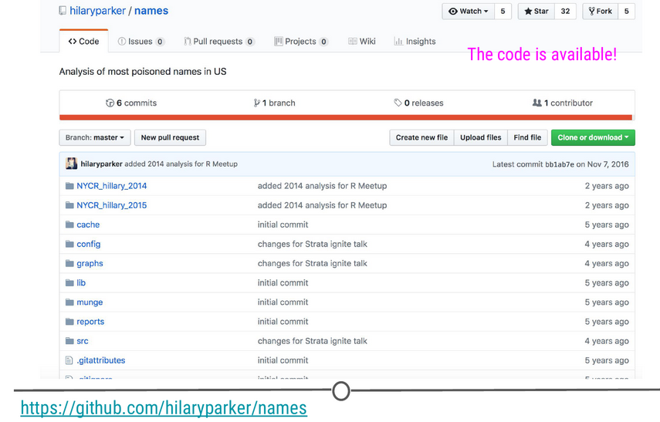
Hilary’s GitHub repo for this project

Exploratory Data Analysis
What you don’t see in the blog post is all of the code Hilary wrote to get the data from the Social Security website, to get it in the format she needed to do the analysis, and to generate the figures. As mentioned above, she made all this code available on GitHub so that others could see what she did and repeat her steps if they wanted. In addition to this code, data science projects often involve writing a lot of code and generating a lot of figures that aren’t included in your final results. This is part of the data science process too. Figuring out how to do what you want to do to answer your question of interest is part of the process, doesn’t always show up in your final project, and can be very time-consuming.

Data Analysis Results
That said, given that Hilary now had the necessary values calculated, she began to analyze the data. The first thing she did was look at the names with the biggest drop in percentage from one year to the next. By this preliminary analysis, Hilary was sixth on the list, meaning there were five other names that had had a single year drop in popularity larger than the one the name “Hilary” experienced from 1992 to 1993.
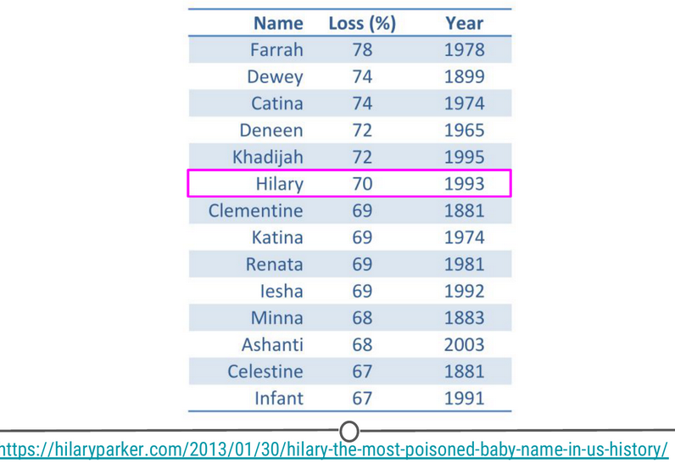
Biggest Drop Table
In looking at the results of this analysis, the first five years appeared peculiar to Hilary Parker. (It’s always good to consider whether or not the results were what you were expecting, from any analysis!) None of them seemed to be names that were popular for long periods of time. To see if this hunch was true, Hilary plotted the percent of babies born each year with each of the names from this table. What she found was that, among these “poisoned” names (names that experienced a big drop from one year to the next in popularity), all of the names other than Hilary became popular all of a sudden and then dropped off in popularity. Hilary Parker was able to figure out why most of these other names became popular, so definitely read that section of her post! The name, Hilary, however, was different. It was popular for a while and then completely dropped off in popularity.
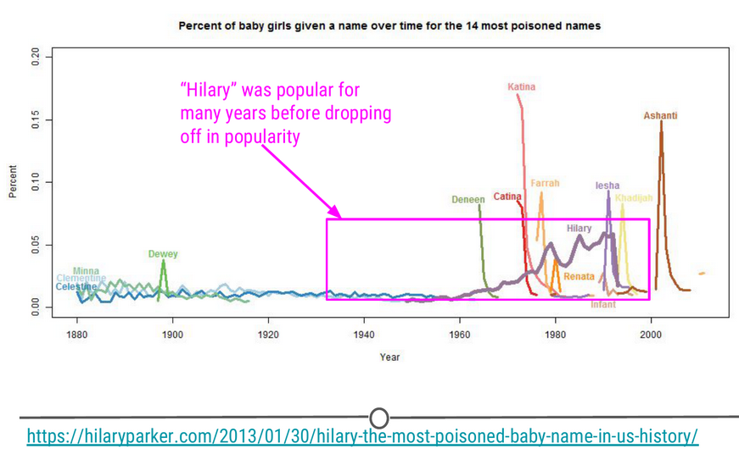
14 most poisoned names over time
To figure out what was specifically going on with the name Hilary, she removed names that became popular for short periods of time before dropping off, and only looked at names that were in the top 1,000 for more than 20 years. The results from this analysis definitively show that Hilary had the quickest fall from popularity in 1992 of any female baby name between 1880 and 2011. (“Marian”’s decline was gradual over many years.)
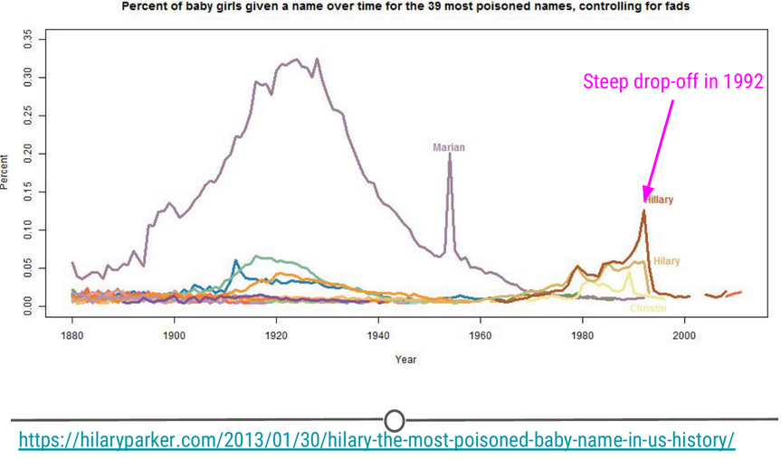

39 most poisoned names over time, controlling for fads

Communication
For the final step in this data analysis process, once Hilary Parker had answered her question, it was time to share it with the world. An important part of any data science project is effectively communicating the results of the project. Hilary did so by writing a wonderful blog post that communicated the results of her analysis, answered the question she set out to answer, and did so in an entertaining way.
Additionally, it’s important to note that most projects build off someone else’s work. It’s really important to give those people credit. Hilary accomplishes this by:
- linking to a blog post where someone had asked a similar question previously
- linking to the Social Security website where she got the data
- linking to where she learned about web scraping

What you can build using R
Hilary’s work was carried out using the R programming language. Throughout the courses in this series, you’ll learn the basics of programming in R, exploring and analysing data, and how to build reports and web applications that allow you to effectively communicate your results. To give you an example of the types of things that can be built using the R programming and suite of available tools that use R, below are a few examples of the types of things that have been built using the data science process and the R programming language - the types of things that you’ll be able to generate by the end of this series of courses.

Prediction Risk of Opioid Overdoses in Providence, RI
Masters students at the University of Pennsylvania set out to predict the risk of opioid overdoses in Providence, Rhode Island. They include details on the data they used, the steps they took to clean their data, their visualization process, and their final results. While the details aren’t important now, seeing the process and what types of reports can be generated is important. Additionally, they’ve created a Shiny App, which is an interactive web application. This means that you can choose what neighborhood in Providence you want to focus on. All of this was built using R programming.
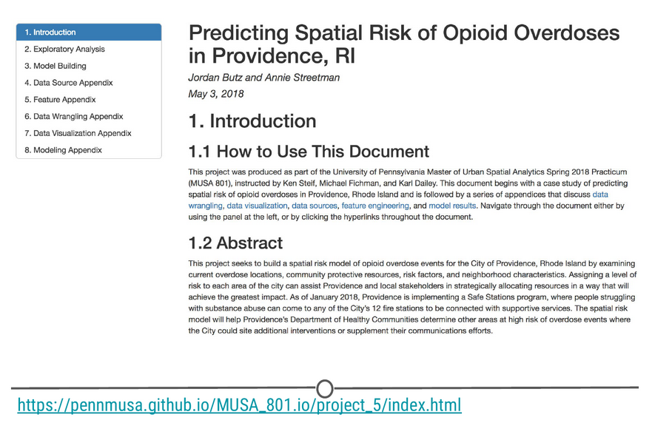
Prediction of Opioid Overdoses in Providence, RI

Other Cool Data Science Projects
The following are smaller projects than the example above, but data science projects nonetheless! In each project, the author had a question they wanted to answer and used data to answer that question. They explored, visualized, and analysed the data. Then, they wrote blog posts to communicate their findings. Take a look to learn more about the topics listed and to see how others work through the data science project process and communicate their results!
- Text analysis of Trump’s tweets confirms he writes only the (angrier) Android half, by David Robinson
- Where to Live in the US, by Maelle Salmon
- Sexual Health Clinics in Toronto, by Sharla Gelfand

Summary
In this lesson, we hope we’ve conveyed that sometimes data science projects are tackling difficult questions (‘Can we predict the risk of opioid overdose?’) while other times the goal of the project is to answer a question you’re interested in personally (‘Is Hilary the most rapidly poisoned baby name in recorded American history?’). In either case, the process is similar. You have to form your question, get data, explore and analyse your data, and communicate your results. With the tools you’ll learn in this series of courses, you will be able to set out and carry out your own data science projects, like the examples included in this lesson!

